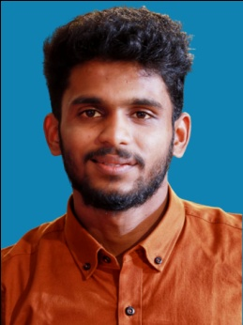

CURRICULUM VITAE

**Carrier Objective**

I would like to work for your organization as an asset and to explore my knowledge and experience of working in the most competent environment where I can give full potential and skills for the best of my organizational interest.

**Education Qualification**

* SSLC
* HSE
* B.com

**Professional Qualification**

Computer Hardware

**Personal Details**

Date of birth : 05-08-1996

Fathers’ Name : Mohan Kumar P K

Nationality : Indian

Religion : Hindu

Marital status : Single

Sex : Male

Languages Known : English, Malayalam.

**Declaration**

I hereby declare and affirm that the above stated particulars are true and correct to the best of my knowledge and belief. I am ready to submit my certificates if it is required.

Place :Vatakara

Date : **ASWIN B**

**ASWIN B**

Moratta ,Nandanam House

Chorode East Post

Vatakara

Kozhikode

673106

Phone :9400907180

Email:aswinboss303@gmail.com

**PERSONAL SKILLS**

* Detail-oriented
* Determination
* Effectively managing multiple projects simultaneously
* [Flexibility](https://www.thebalancecareers.com/workplace-flexibility-definition-with-examples-2059699)
* Focused
* Recovering quickly from setbacks
* Respectful
* Responsible